**4. Docker Basics**

1. List few benefits of docker

* It alleviate the problem that it’s broken on my machine. With docker development environment is exactly same as the production environment and exactly same as everyone else’s development environment.
* Docker organize code for deploying on new services
* With docker can run multiple separate containers (separate versions of php)

1. Install docker
2. Check docker version and copy the output

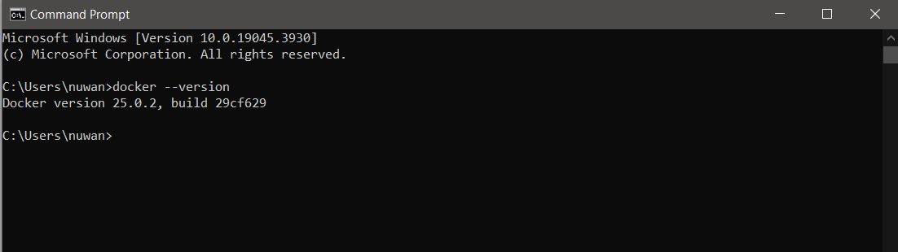

1. Create a new java project with maven
2. Create a main class and print “Hello docker example”
3. Create a jar file for the project (inside target directory)

mvn package

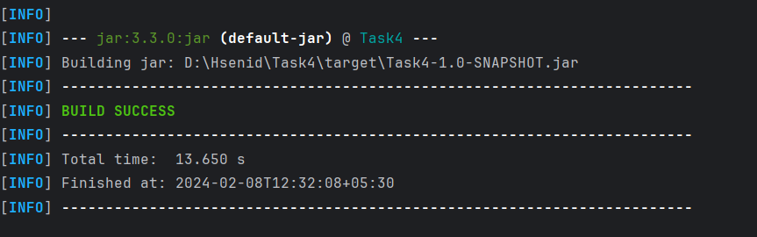

1. Run the generated jar file inside target directory with command line
2. Display the output

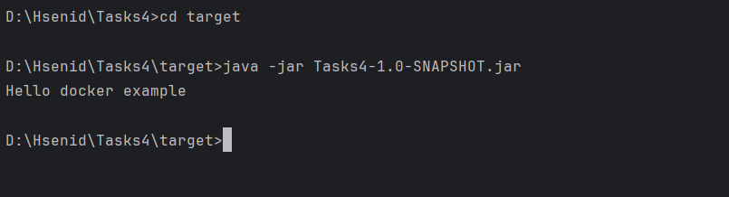

1. Create a docker image for the java project. What is the command you used?

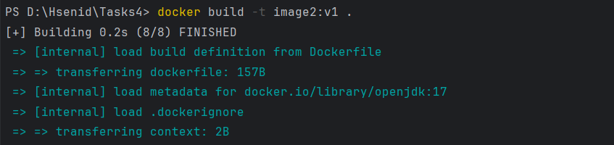

1. List all the docker images and show output

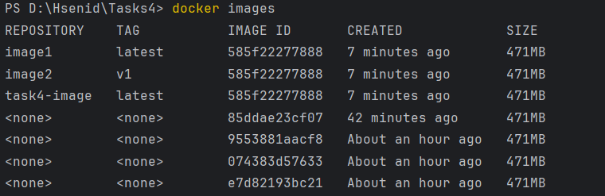

1. Run the created docker image. What is the command you used

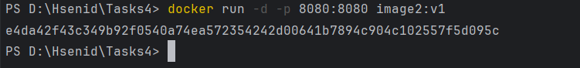

1. List all the docker images and show output

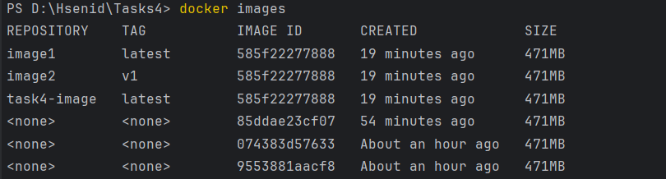

1. Stop the docker container?
2. List all the docker containers and show output

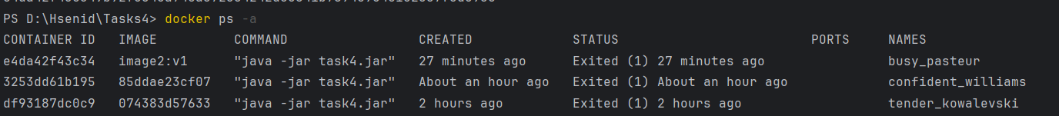

1. 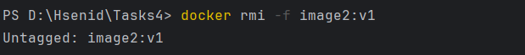Remove the docker image. What is the command you used?
2. List all the docker images and show output

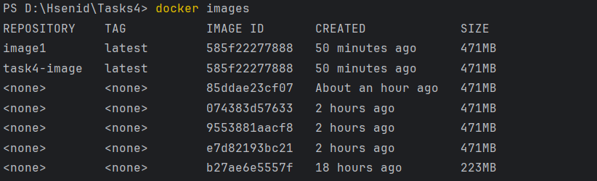

1. What is docker hub?

Docker hub is cloud- based repository service, it is a kind of storage where we can store and pull docker container images when required. Can push images as private or public. Docker hub is an open-source tool and freely available for all operating systems.

1. 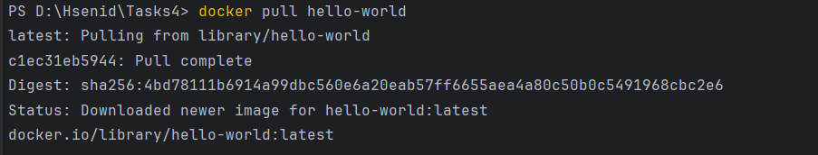Pull hello-world image from docker hub
2. Run hello-world image and show output

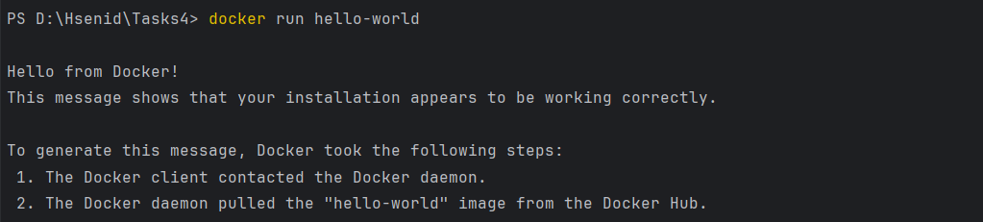

1. Pull and run mongodb as docker container

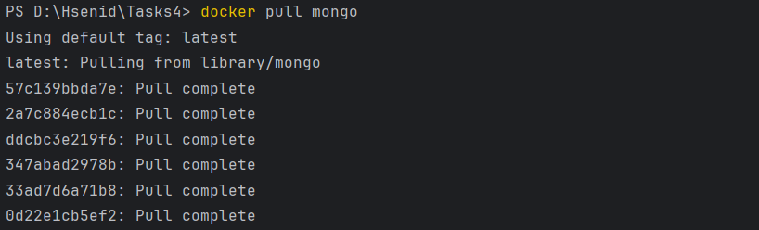



1. Open mongo shell

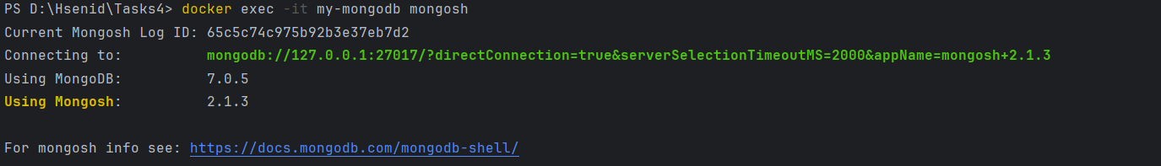

1. List mongodb databases

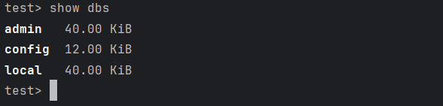

1. Add your codes and answer sheet to a directory named “docker-basic-training” and push it to your training github repository

